New Job
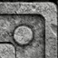
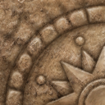
As many of you know I recently graduated with an Undergraduate degree in History with my concentration being on American History. Before graduation I applied to the Civil War Museum of the Carolinas for the position of curator, shortly after graduation I began working. The museum is amazing; I’m surrounded by tangible pieces of the history I loved in the classroom. My coworkers are very friendly and have made me feel welcome. Most of my responsibilities are to make sure the exhibits are properly taken care of. I also log the new artifacts that come in to the museum and I’m responsible for the assembly of new displays. I plan to continue my education while working here and eventually I would like to travel the country lecturing about the things I have seen and the new discoveries that have come my way through the museum. I have also been given the opportunity through the museum to go out on field study expeditions, this is something that I have always wanted to do.

New City

I I enjoy my new job and I really enjoy the move I made to charlotte. The city is fun and full of life. It was difficult at first to get accustomed to city living; the crowded streets and noisy atmosphere, but eventually the city showed its charm. It took me some time to get used to the morning commute; my attempts to make a mental map of the maze of downtown charlotte was difficult, eventually I found my bearings and learned to deal with heavy traffic to and from work.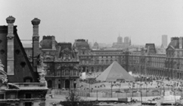

The apartment I live in is spacious and well furnished and I find it to be a quite retreat from the noisy streets below. There is a lot to see and do in the city: museums, theaters, fine restaurants and art galleries. I think there is enough in this city to keep me entertained for a long time to come.
The weather in the city isn’t the best, when it rains it pours and when it’s cold it frosts. At least I get to see the seasons change from the high view of my apartment.

- Jamie Williams

